Jason Bateman

eLearning Portfolio

## Persuasion - Toolwire

The focus of this training was on using the AIDA model for persuasion. In this example, the user attempts to persuade an executive to adopt a new metrics tracking tool. As the user makes selections based on emotion or logic, the executive responds accordingly. At the same time, the Persuasion Meter adjusts, letting the user know how successful they were in convincing the executive.

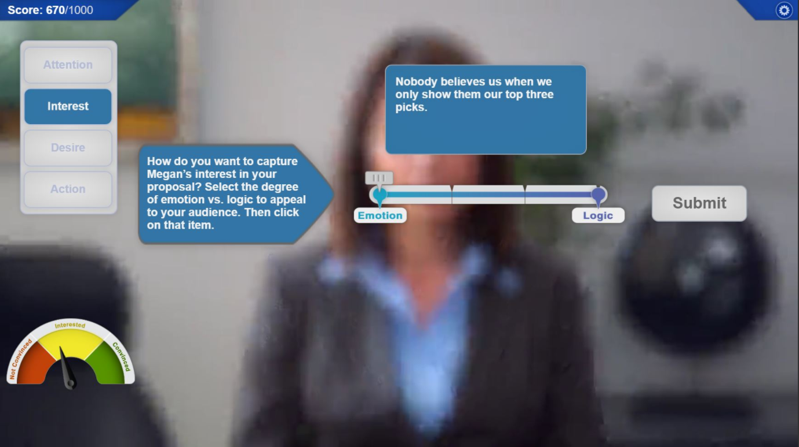

## Communication - Toolwire

In this scenario the user encounters a meeting in progress. The meeting is inherently flawed. The student identifies communication weaknesses in the meeting and guides the organizer in creating a more effective meeting.

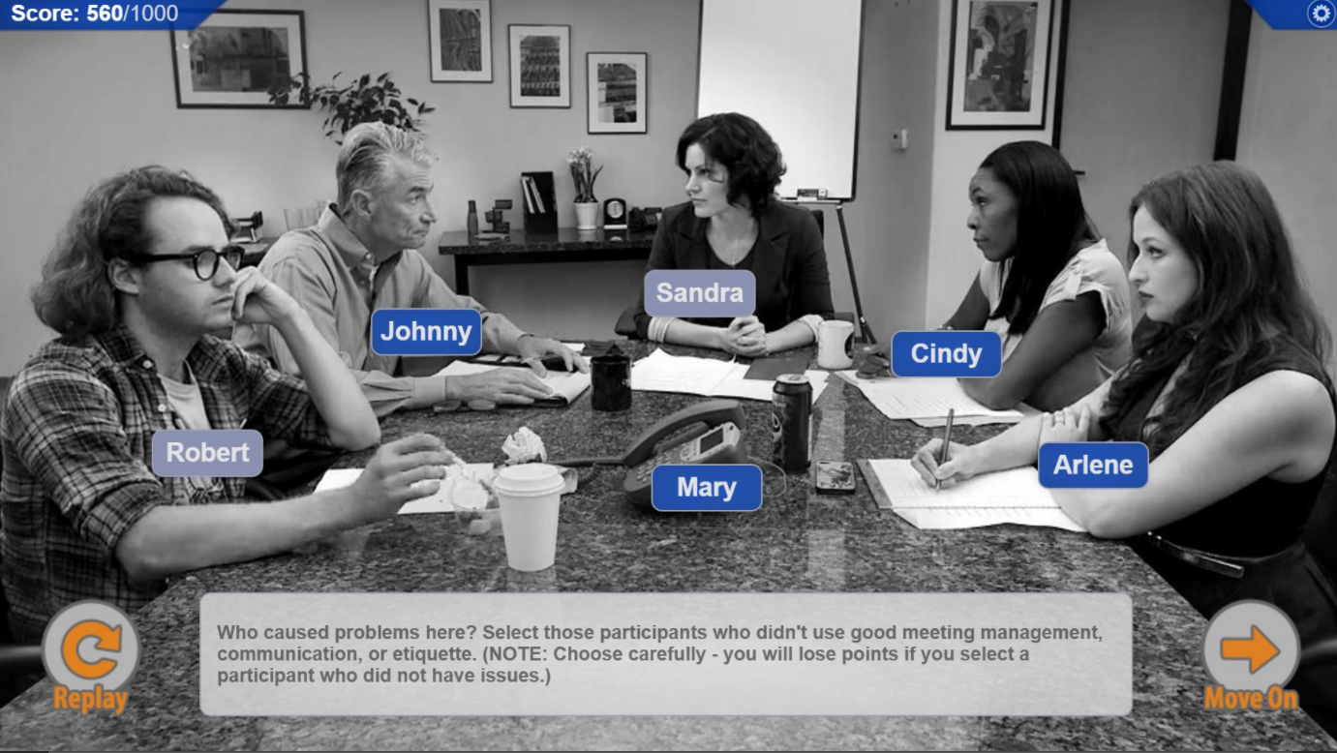

## Business Ethics & Social Responsibility - Toolwire

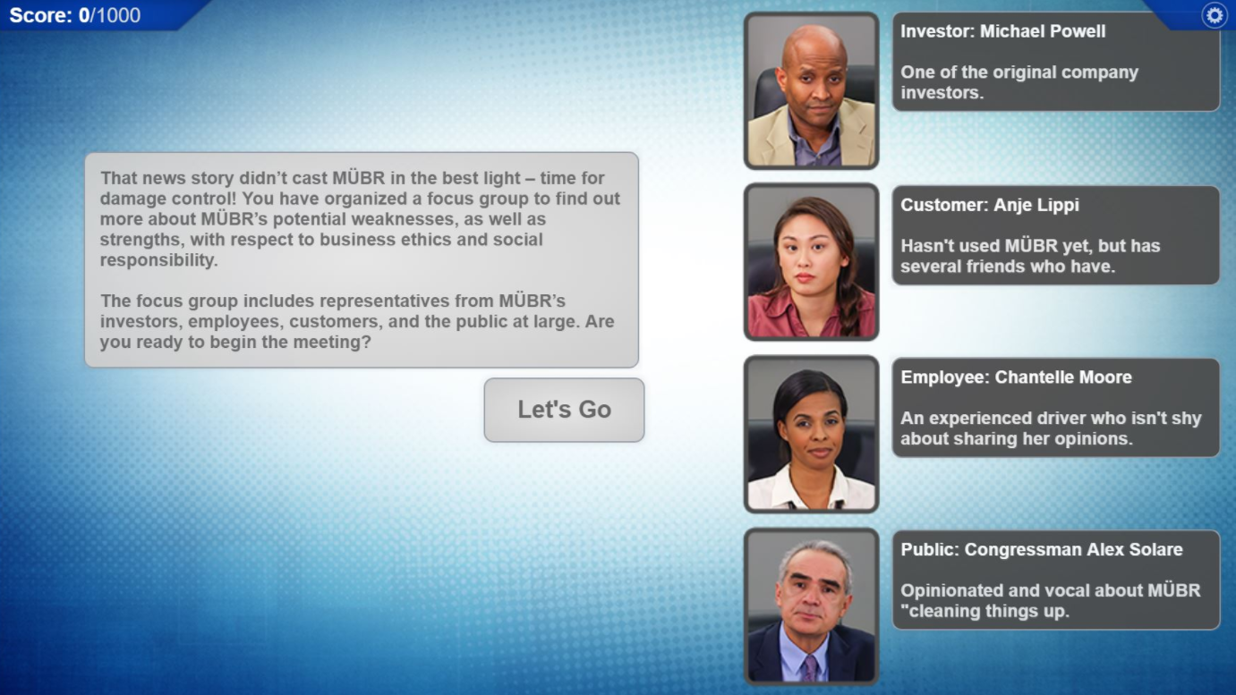This was a business game for first year business students. In this game, the user is placed in a scenario in which they hear the various sides of a business proposal in order to guide the company to the correct decision.

## Business Basics - Toolwire

This was a business game for first year business students. In this game, the user selects a business and determines the method for competing in that market over a specified timeline. The student aims to stay in business and reach a specific dollar amount.

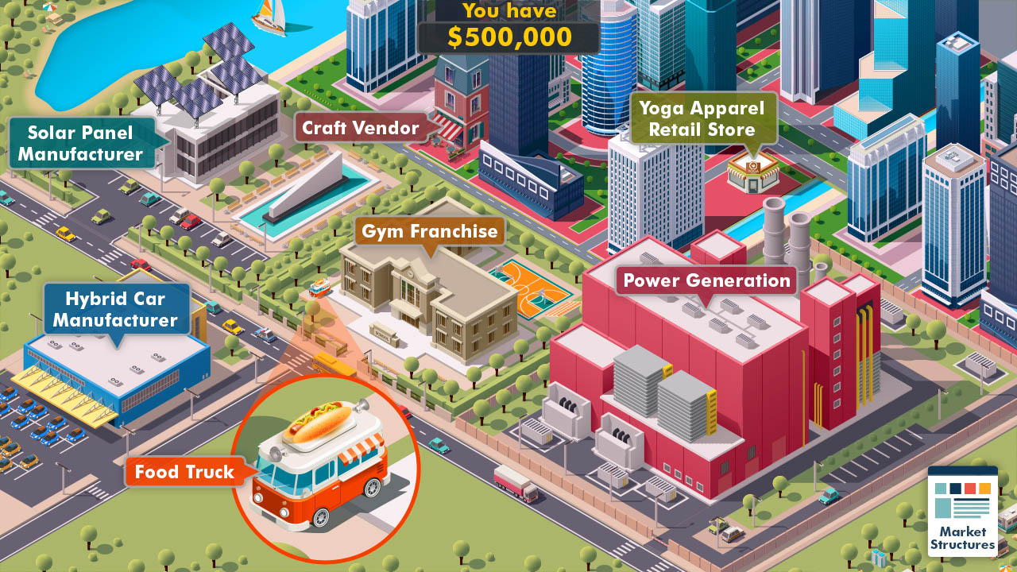

## Chemical Safety - PG&E

This scene is a simple multiple question scenario.

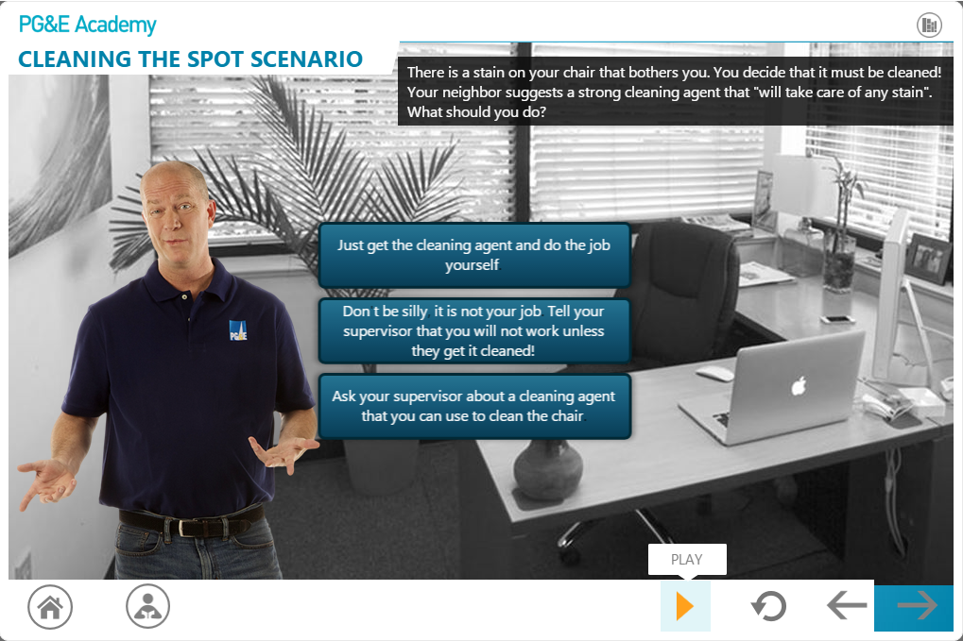

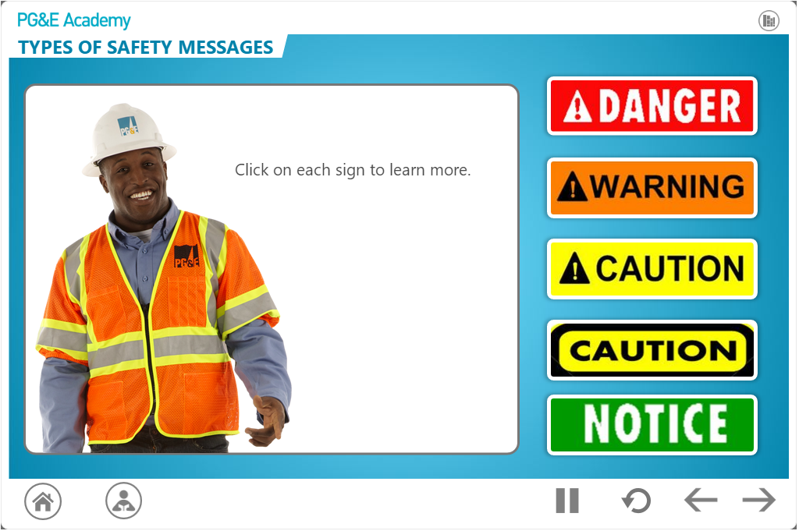

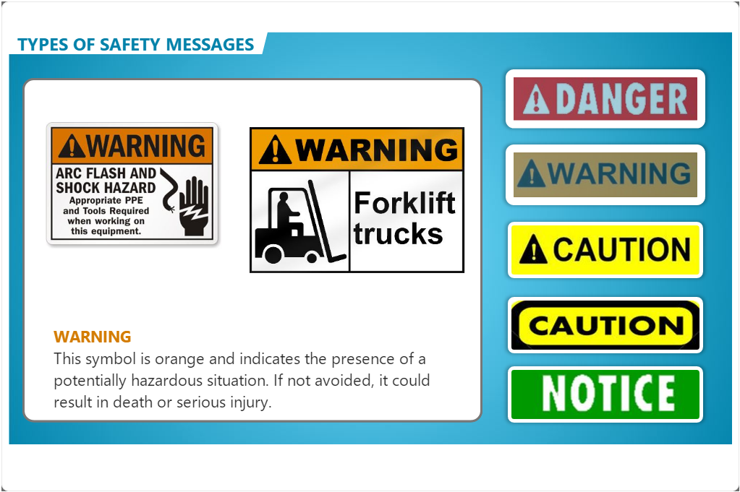

This is the dashboard from the aerial lift course. Each segment would be updated as it was completed.

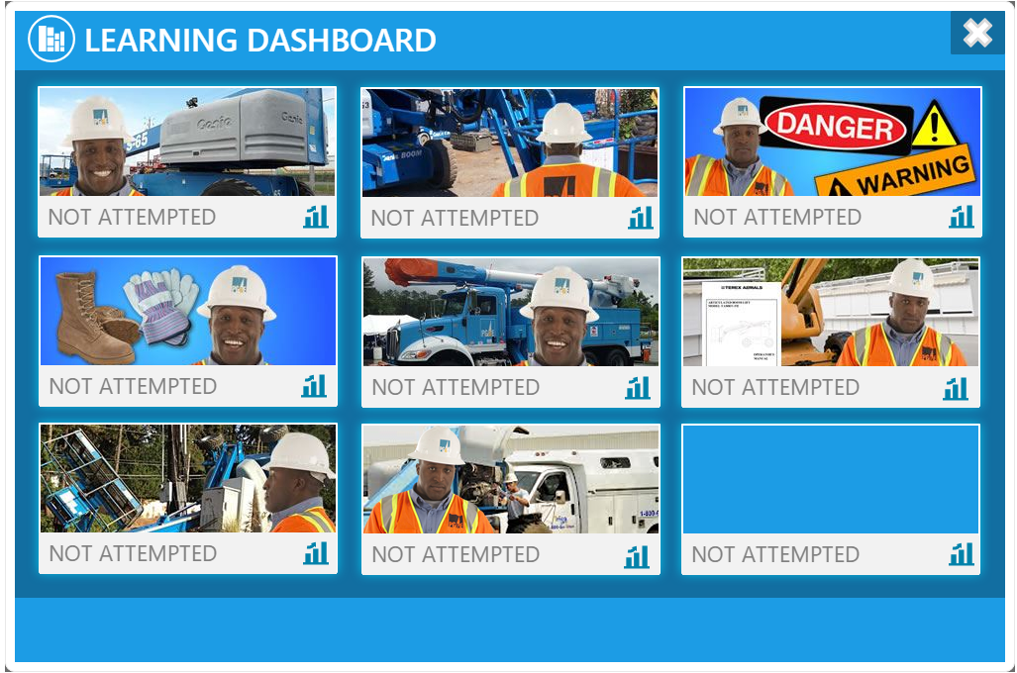

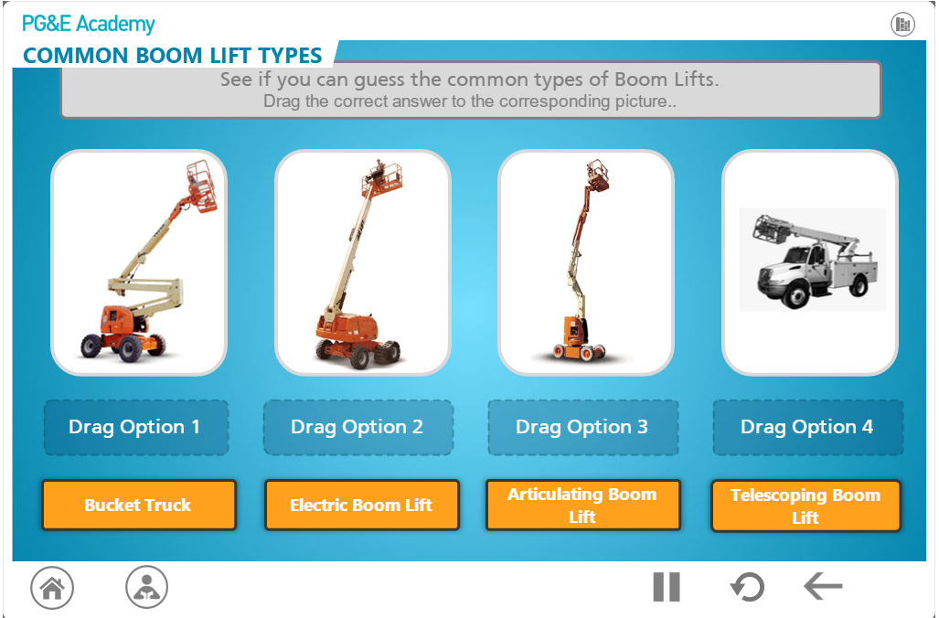

## Project Management - ELearning Brothers for The Project Management Institute (PMI)

This is a segment from the PMI course in which our character discusses some of the project constraints.

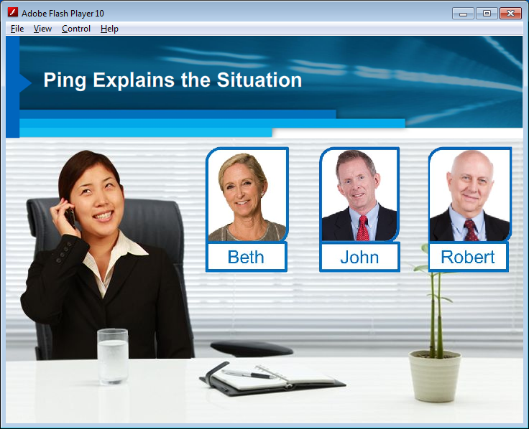

From the same course, the user builds a program roadmap. This involves dragging and dropping each of items on the screen in its correct location.

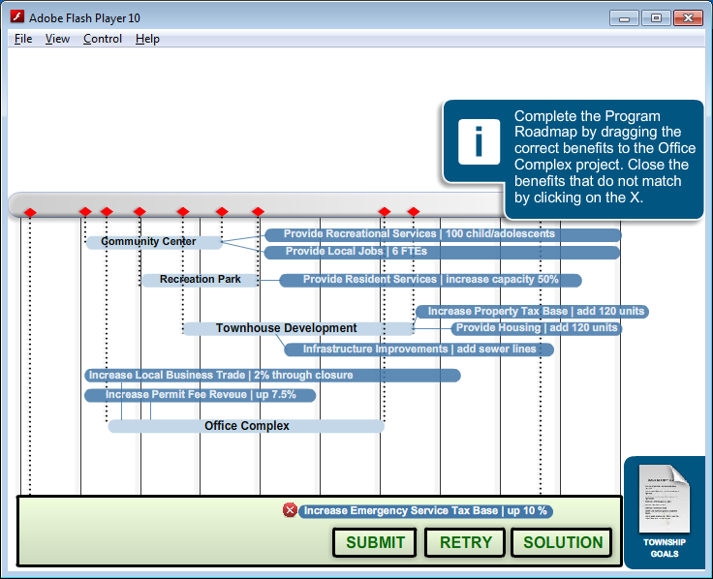

Another screenshot from the same course.

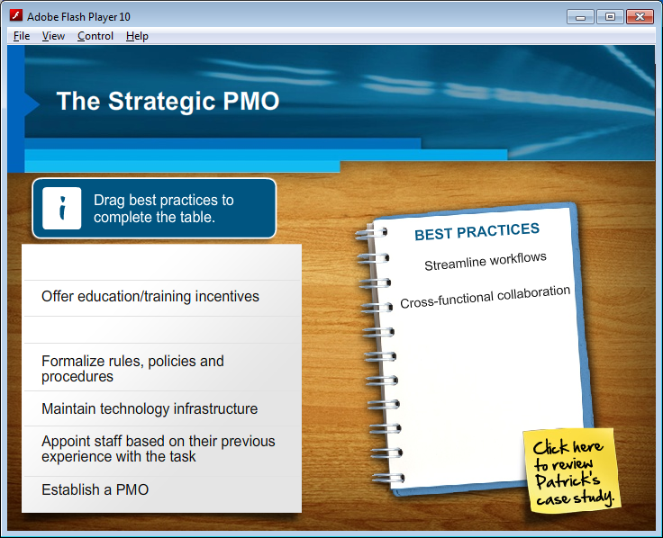

## ACAMS Reader - Tooele Chemical Agent Disposal Facility

This course gave employees an opportunity to practice using our air monitoring instrument in a safe environment. They answer several questions and then help the two entrants to migrate from the A airlock to the B airlock and into a C area. This simulation was a blended solution and was the final step in a classroom course.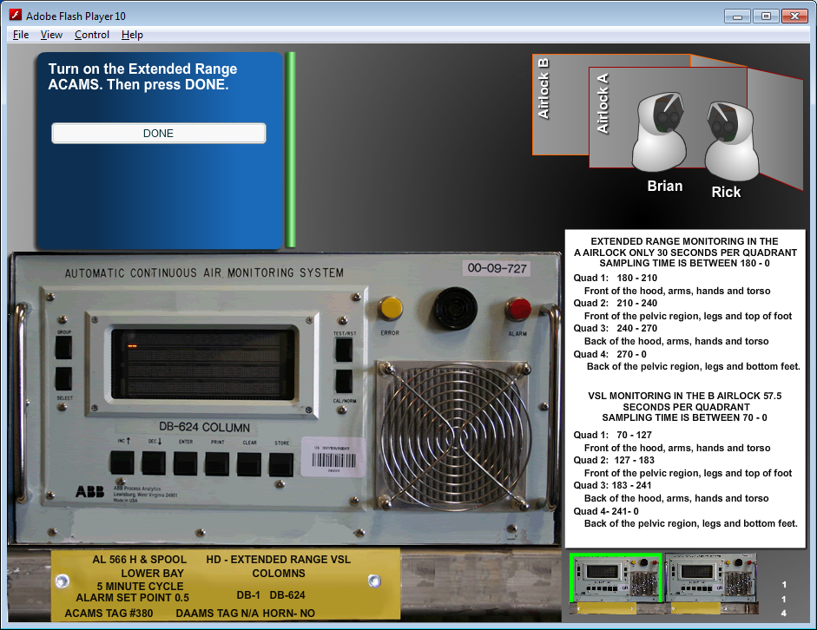

## Emergency Response - Tooele Chemical Agent Disposal Facility

This is an animation showing how to rescue an entrant if they were to “go down” in a toxic area.

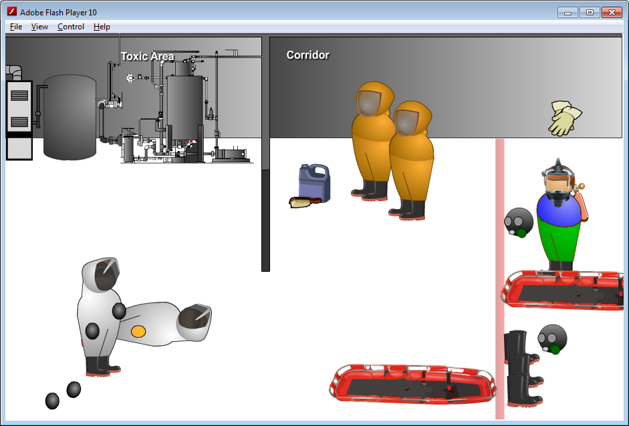

## Emergency Response - Tooele Chemical Agent Disposal Facility

This is from our emergency response course that identifies the various roles of the response teams.

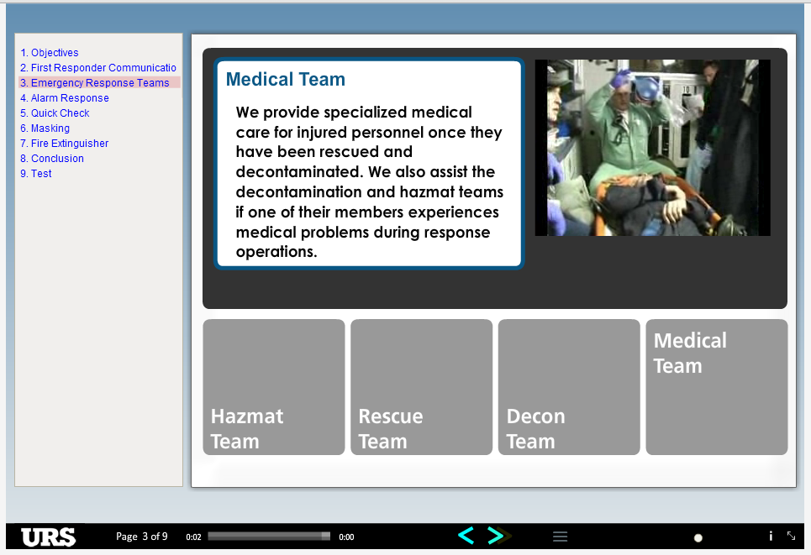

## URS for the Tooele Chemical Agent Disposal Facility

This is one of several software simulations that walks the employee through Maximo. The user is tasked with completing the problem noted on the sticky note. If they click the incorrect location, the red box appear to prompt them. They are losely graded on the number of clicks they get correct.

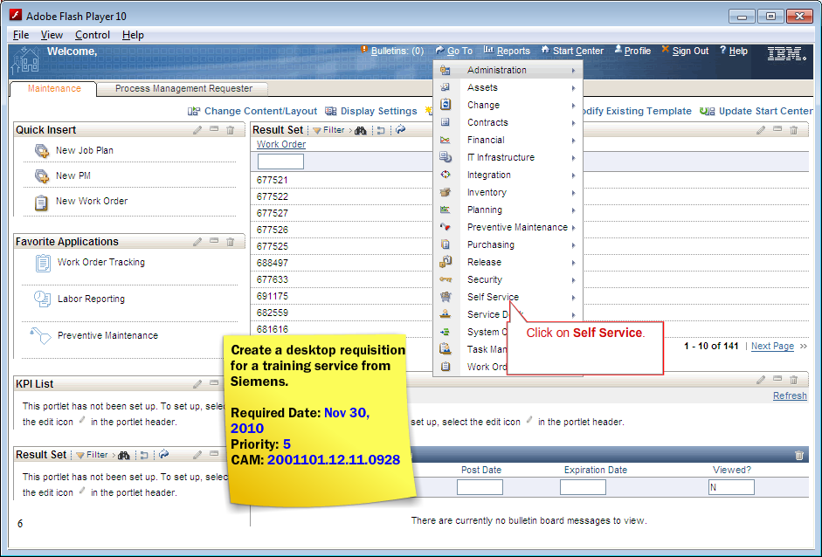

## ELISA Testing - ARUP Laboratories

This course helped medical technicians understand the chemical reaction when running an ELISA test. ARUP did not allow us to have speakers, so you will notice that these courses were very text heavy.

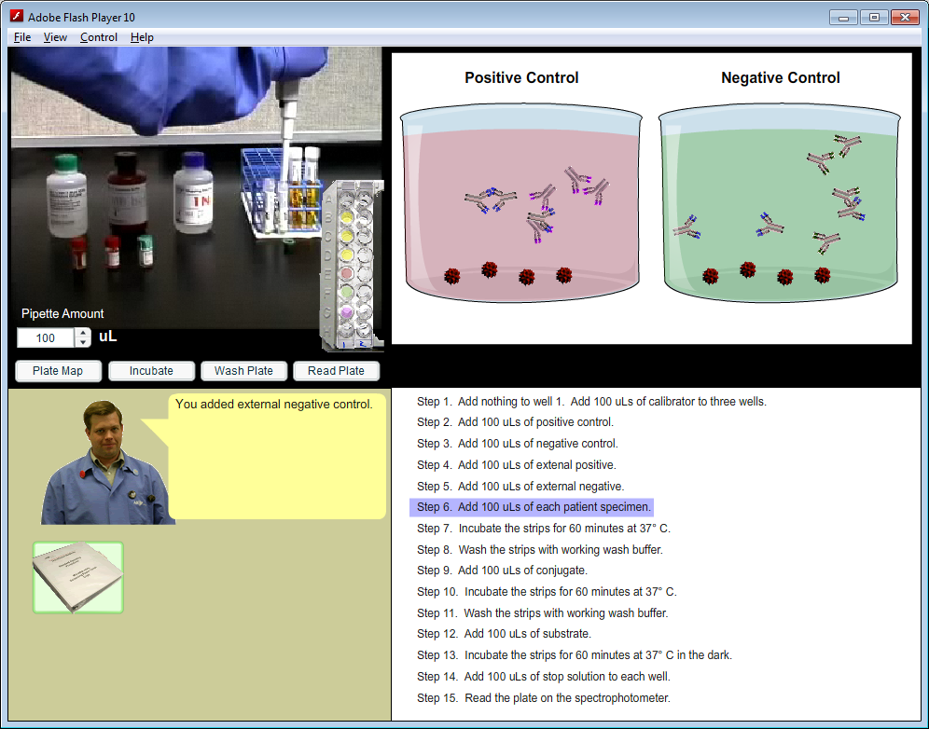

## Blood Donor Medical Evaluation - ARUP Laboratories

This course helped new donor center employees ask the right questions and determine if an individual was allowed to donate blood, or give them an appropriate deferral time. This course improved knowledge retention and reduced training time from 2 weeks to a three hours by presenting 10 increasingly difficult scenarios.

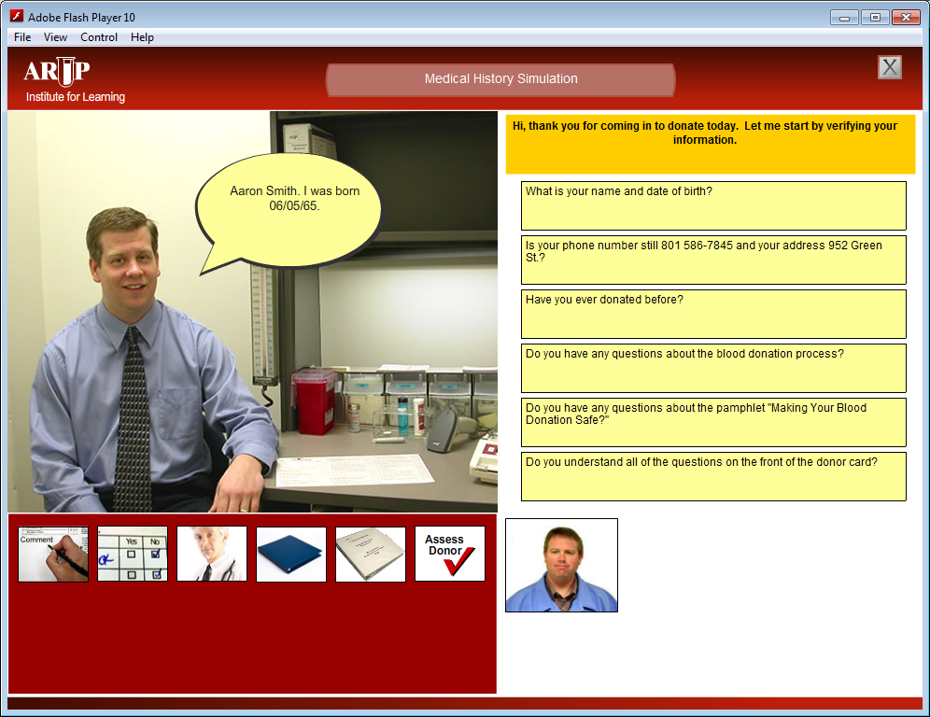

Another screen shot of the same course. Here they review the donor card and select the items that require additional attention.

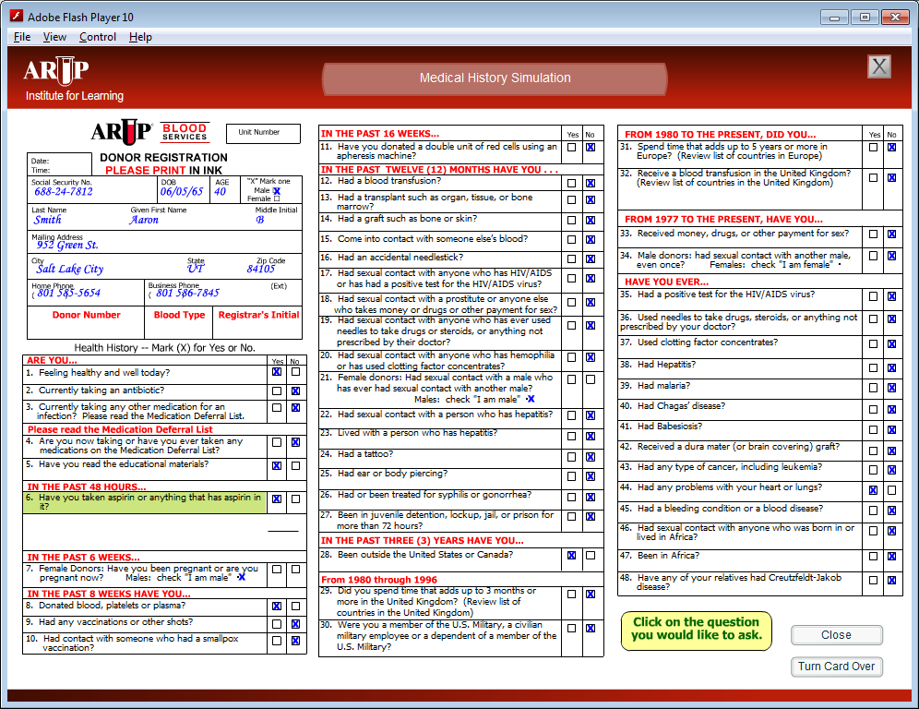

Ransomware Fire Drill: Module 1 - Steady State Security

<https://druva.wistia.com/medias/g7jm8viheb>

Ransomware Fire Drill: Module 2 - Attack and Discovery

<https://druva.wistia.com/medias/ek0iol8iug>

Ransomware Fire Drill: Module 3 - Attack Investigation and Response

<https://druva.wistia.com/medias/evopchhn91>

Ransomware Fire Drill: Module 4 - Recovery and Remediation

<https://druva.wistia.com/medias/6j8k8t6jrb>

Ransomware Fire Drill: Module 5 - Lessons Learned

<https://druva.wistia.com/medias/v14wx0kty8>